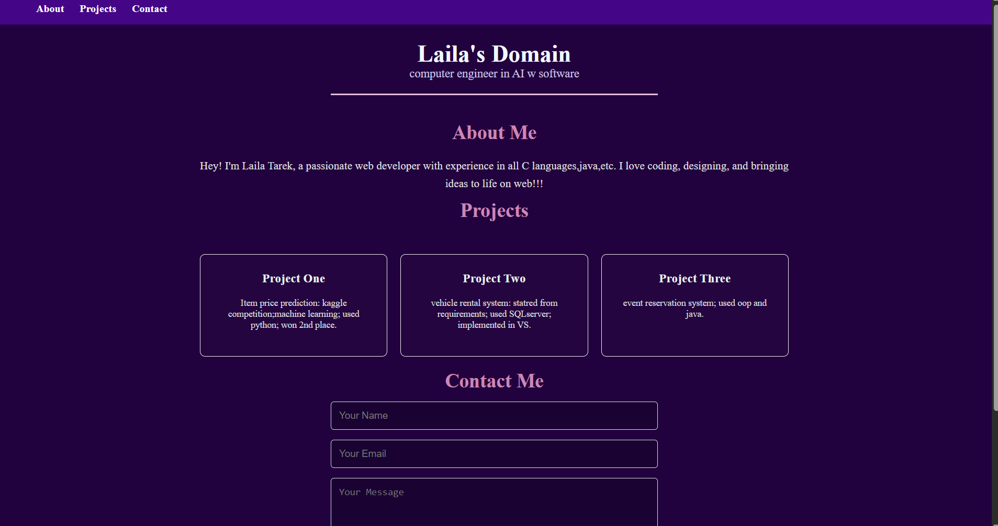


Repo link: https://github.com/lailatarekk/web-dev.git

